# Laboratory 3

1. Title of the Laboratory Exercise: Program to count no of:
   1. +positive and –negative integers
   2. +positive and –negative fractions
2. Introduction and Purpose of Experiment

.

1. Aim and Objectives

Aim

Objectives

At the end of this lab, the student will be able to

1. Experimental Procedure

Students are required to carry out the following steps:

* Algorithm
* Write the Lex program
* Compile and execute the program (steps)
* Complete the documentation for the given problem

1. Presentation of Results

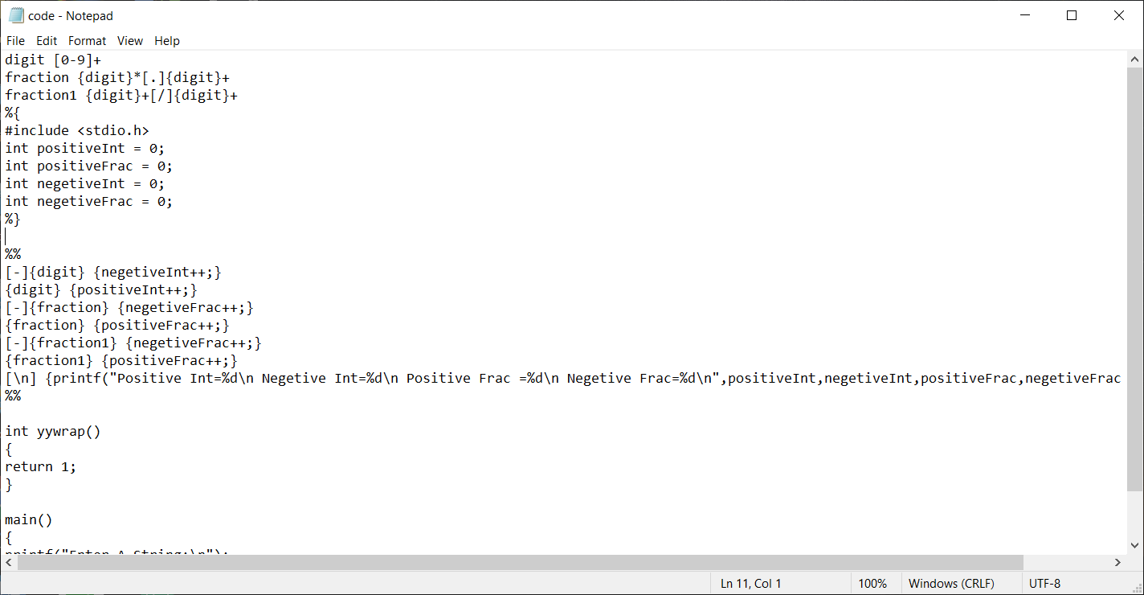

Image 1: Code

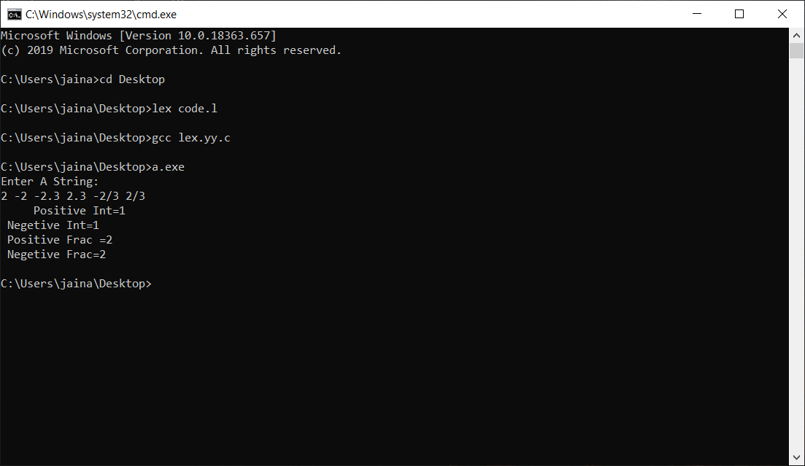

Image 2: Output

1. Analysis and Discussions

In this lab we are asked to make a program which can calculate number of positive integers, negative integers, positive fraction and negative fraction

In any lex code there are three sections

* In the first section that is the definitions section we have declared the meaning of integer, decimals and fractions, in this code we are considering both decimals and fractions to be fractions itself also we declared four integer variables to manage the counter for the same.
* In the second section that is pattern action section we are writing code to identify positive integers, negative integers, positive fraction and negative fraction and increment the corresponding counter for the same. And also there is a logic for new line character, when pressed it will display the result showing number of each entities.
* In the third section that is user code section we are asking user to enter the string.

1. Conclusions

As we can see that the output that we are getting is correct for the given string input and the code is working correctly.

1. Comments

a. Limitations of Experiments

It only calculates number of positive integers, negative integers, positive fraction and negative fraction, we can expand the logic to identify various other types of numbers like complex numbers etc.

b. Limitations of Results

The result that we are getting is showing result by combining decimal numbers and fractions to be fraction itself it can be modified in such a way that decimal numbers and fraction number can have different count.

c. Learning happened

We learn how to use one declaration is definition of another declaration, for example digit is defined as [0-9] + and later this digit is use to define decimals and fractions.

d. Recommendations

Although utmost care has been taken while creating this document in the given time constraint but there is always room for errors and its correction and improvements.

|  |  |  |
| --- | --- | --- |
| **Component** | **Max Marks** | **Marks Obtained** |
| **Viva** | **6** |  |
| **Results** | **7** |  |
| **Documentation** | **7** |  |
| **Total** | **20** |  |